Additional file 1
Gel Electrophoresis Pictograms
Amplification of the atr housekeeping gene.
PCR was done to detect the presence of housekeeping genes. Forty-three genomic DNA samples were amplified using primers targeting for presence of the gene: atr (780bp) in GBS. Fig 1 shows the results for the housekeeping gene, atr.
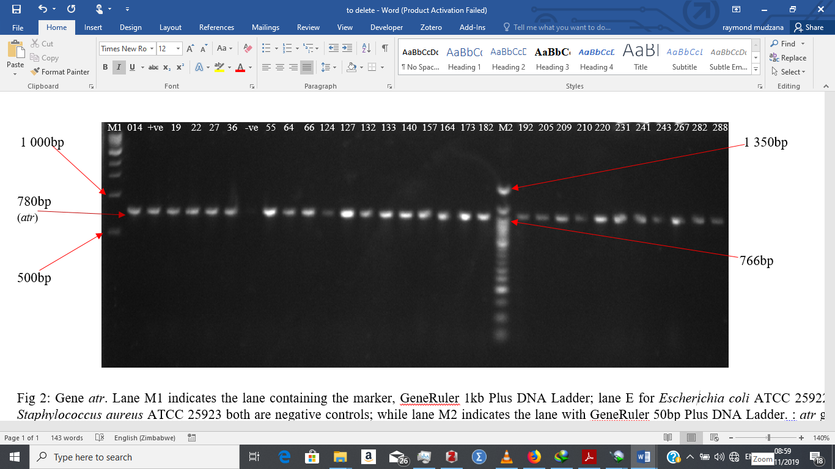
Fig 1: Gel electrophoresis of the atr gene. Lane M1 indicates the lane containing the marker, GeneRuler 1kb Plus DNA Ladder; lane +ve for the positive control; lane -ve for the negative control;; while lane M2 indicates the lane with GeneRuler 50bp Plus DNA Ladder. : atr gene (780bp) present in all the other 43 GBS isolate.
Amplification of the Mobile Genetic Element, IS1548 .
PCR was done to detect the presence of MGE. All forty-three genomic DNA samples were amplified using primers targeting for presence of the gene: IS1548 (690bp) in GBS. Fig 2 shows the results for the MGE, IS1548.
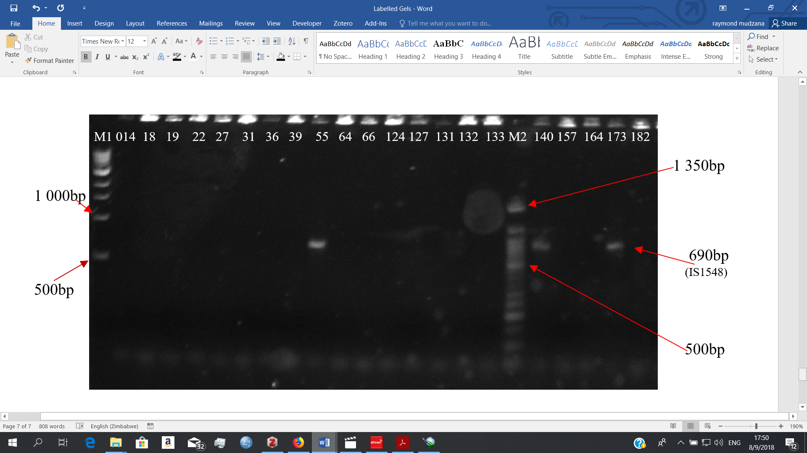
Fig 2: Gel electrophoresis of the Mobile Genetic Element IS1548. Lane M1 indicates the lane containing the marker, GeneRuler 1kb Plus DNA Ladder; while lane M2 indicates the lane with GeneRuler 50bp Plus DNA Ladder. : IS1548 gene (690bp) present in GBS isolates 55, 140 and 173 but absent in the rest of the isolates.
Amplification of the genes atr, bac and tetO.
All forty-three genomic DNA samples were amplified using PCR primers targeting for presence of the following genes: atr (780bp), bac (592bp) and tetO (538) in GBS. Fig 3 shows the results for three genes.
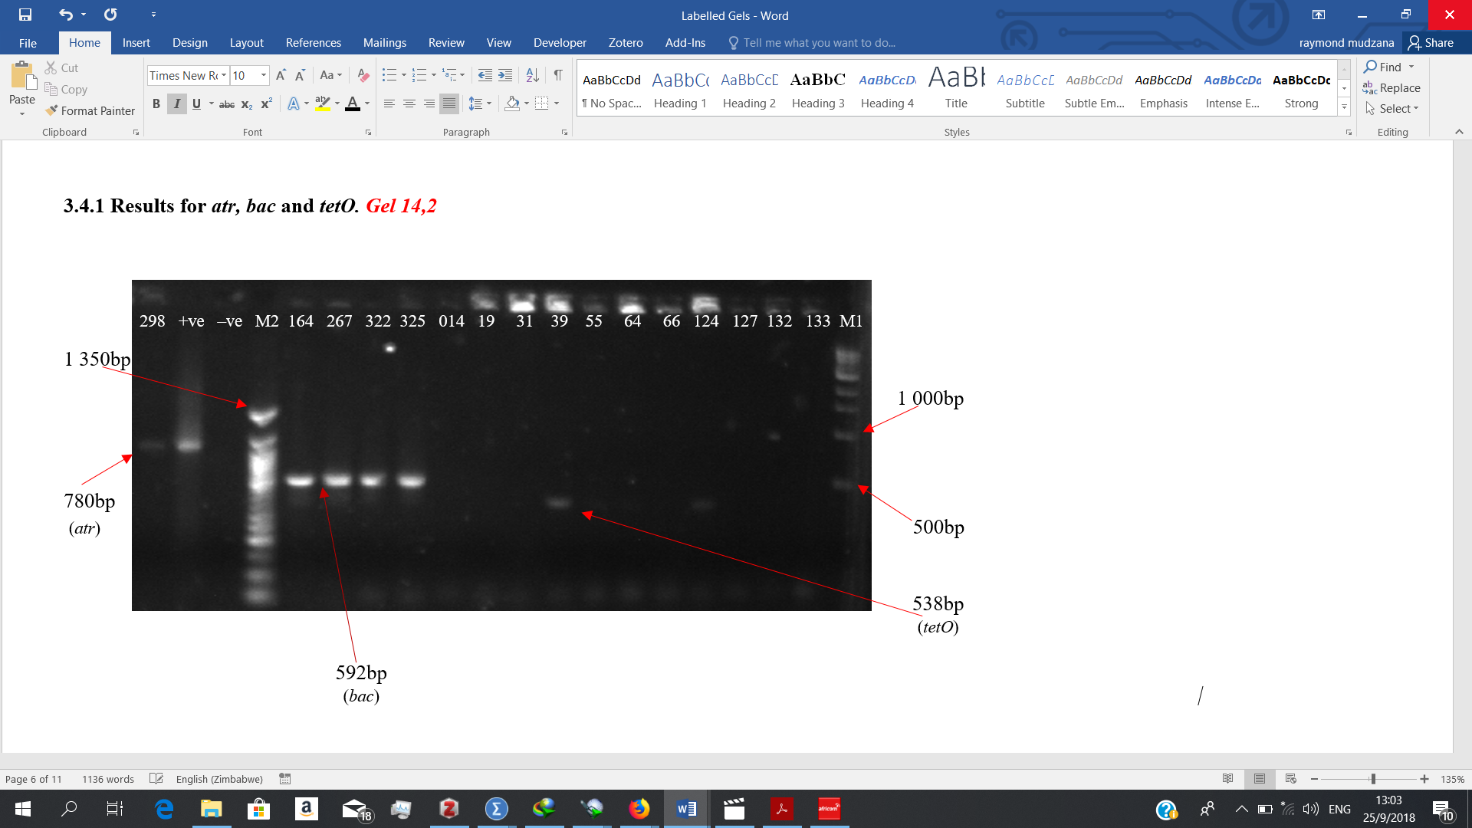
Fig 3: Gel electrophoresis of the atr, bac and tetO genes. Lane M1 indicates the lane containing the marker, GeneRuler 1kb Plus DNA Ladder; while lane M2 indicates the lane with GeneRuler 50bp Plus DNA Ladder. : atr gene (780bp) present in GBS isolate 298 and the positive control but absent in the negative control. bac gene (592bp) present in GBS isolate 164, 267, 322 and 325. tetO gene (538) present in GBS isolates 39 and 124 but absent in isolates 014, 19, 31, 55, 64, 66, 127, 132 and 133.
Amplification of the genes scpB, ermB and rib.
All forty-three genomic DNA samples were amplified using PCR primers targeting for presence of the following genes: scpB (255), ermB (640) and rib (369) in GBS. Fig 4 shows the results for three genes.

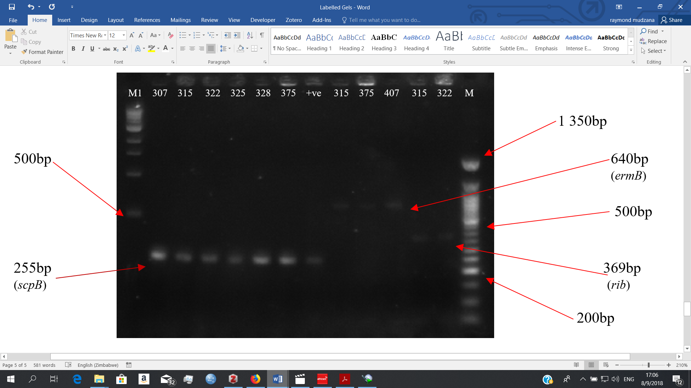
Fig 4: Gel electrophoresis of the scpB, ermB and rib genes. Lane M1 indicates the lane containing the marker, GeneRuler 1kb Plus DNA Ladder; lane +ve for the positive control; while lane M2 indicates the lane with GeneRuler 50bp Plus DNA Ladder. : scpB (255bp) present in GBS isolates 307, 315, 322, 325, 328, 375 and the positive control. ermB (640bp) present in GBS isolates 315, 375 and 407. rib (369bp) present in GBS isolates 315 and 322.
Amplification of the genes linB, rib, hly and scpB.
All forty-three genomic DNA samples were amplified using PCR primers targeting for presence of the following genes: linB (944), rib (369), hly (199) and scpB (255) in GBS. Fig 5 shows the results for three genes.
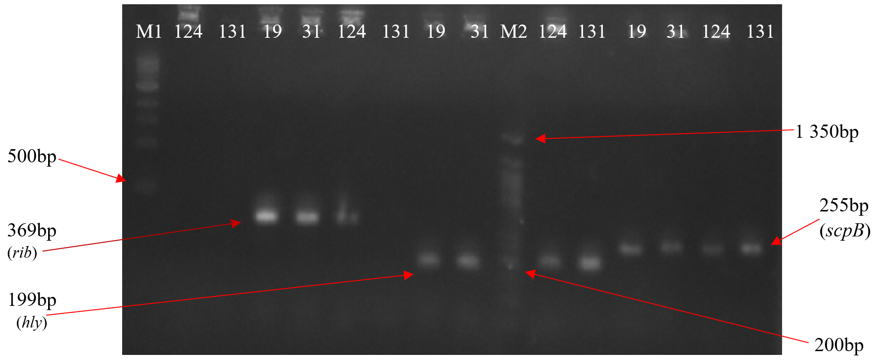
Fig 5: Gel electrophoresis of the linB, rib, hly and scpB genes. Lane M1 indicates the lane containing the marker, GeneRuler 1kb Plus DNA Ladder; while lane M2 indicates the lane with GeneRuler 50bp Plus DNA Ladder. : linB (944bp) absent in GBS isolate 124 and 131. rib (369bp) present in GBS isolates 19, 31, 124 but absent in 131. hly (199bp) present in GBS isolates 19, 31,124 and 131. scpB (255bp) present in GBS isolates19,31,124 and 131.
Amplification of the gene bca.
All forty-three genomic DNA samples were amplified using PCR primers targeting for presence of the virulence gene: bca (535bp) in GBS. Fig 6 shows the results for the bca gene.

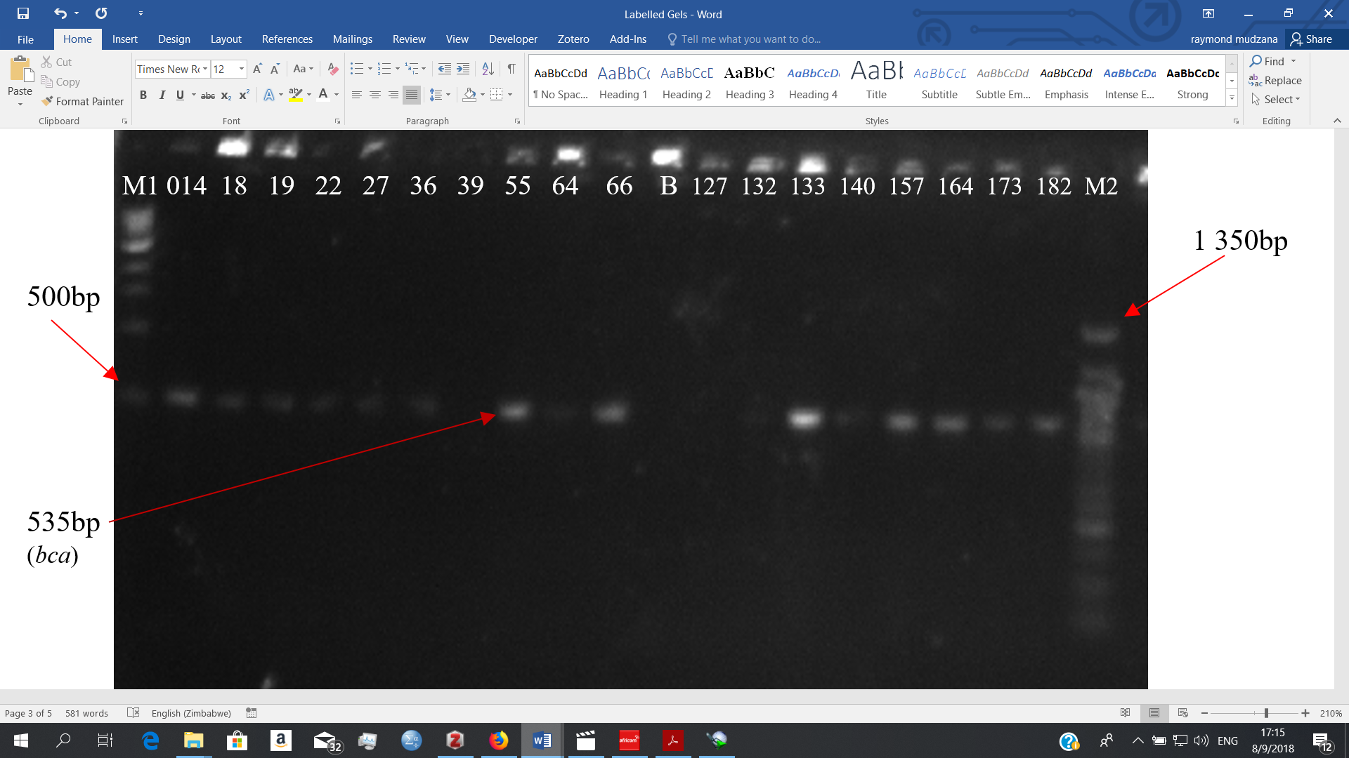
Fig 6: Gel electrophoresis of the bca gene. Lane M1 indicates the lane containing the marker, GeneRuler 1kb Plus DNA Ladder; lane B for the blank/negative control; while lane M2 indicates the lane with GeneRuler 50bp Plus DNA Ladder. : bca (535bp) absent in GBS isolate B(blank), 39, 127 and 131.
Amplification of the genes bac, mefA and tetO.
All forty-three genomic DNA samples were amplified using PCR primers targeting for presence of the following genes: bac (592bp), mefA (348bp) and tetO (538bp) in GBS. Fig 7 shows the results for three genes.

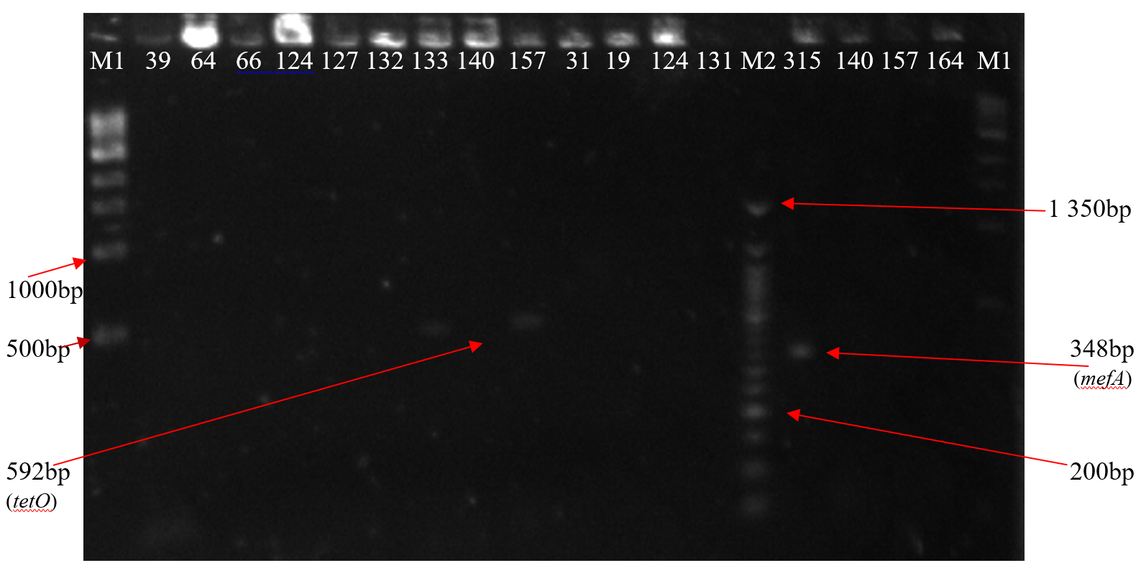
Fig 7: Gel electrophoresis of the bac, mefA and tetO genes. Lane M1 indicates the lane containing the marker, GeneRuler 1kb Plus DNA Ladder; while lane M2 indicates the lane with GeneRuler 50bp Plus DNA Ladder. : bac (592bp) present in GBS isolate 133 and 157 but absent in GBS isolates 39, 64, 66, 124, 127, 132, 140, 31, 19, 124 and 131. mefA gene (348bp) present in GBS isolate 315. tetO (538bp) absent in GBS isolates 140, 157 and 164.
Amplification of the genes ermTR and bac.
All forty-three genomic DNA samples were amplified using PCR primers targeting for presence of the following genes: ermTR (400bp) and bac (592bp) in GBS. Fig 8 shows the results for two genes.
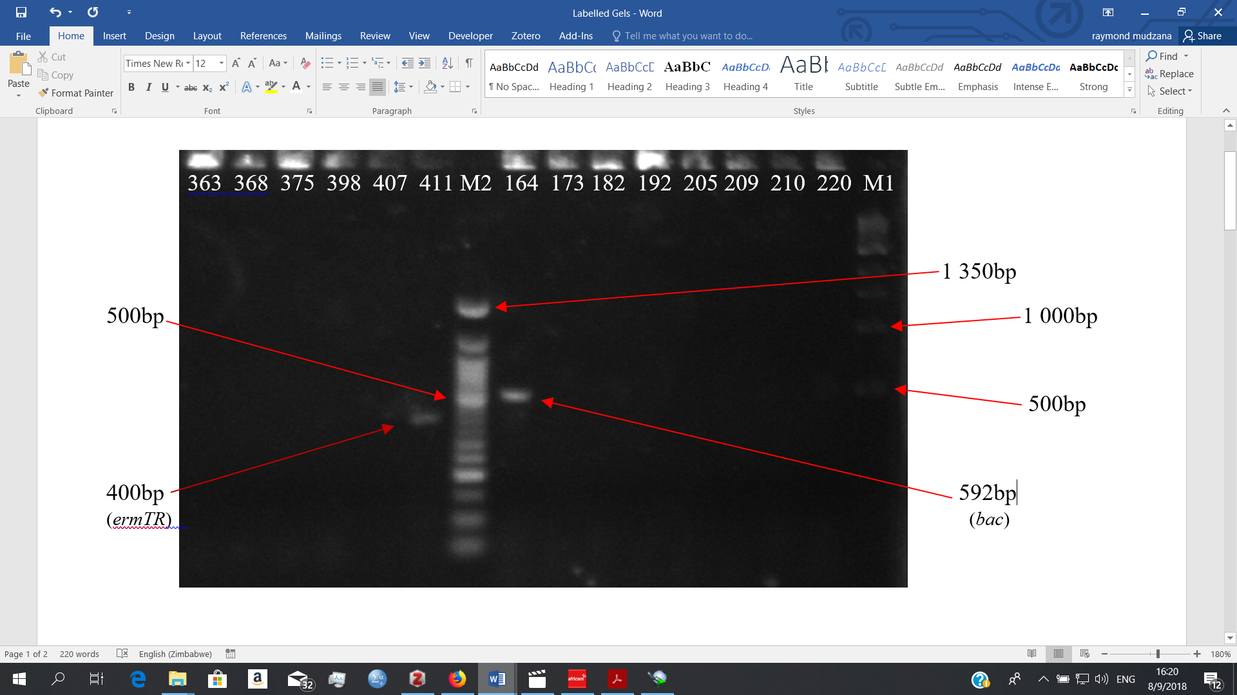
Fig 8: Gel electrophoresis of the ermTR and bac genes. Lane M1 indicates the lane containing the marker, GeneRuler 1kb Plus DNA Ladder; while lane M2 indicates the lane with GeneRuler 50bp Plus DNA Ladder. : ermTR gene (400bp) present in GBS isolate 411 but absent in 363, 368, 375 and 407. bac (592bp) present in GBS isolate 164 but absent in GBS isolates 173, 182, 192,205, 209, 210 and 220.
Amplification of the gene tetM.
All forty-three genomic DNA samples were amplified using PCR primers targeting for presence of the following antibiotic resistance gene: tetM (359) in GBS. Fig 9 shows the results for one gene.
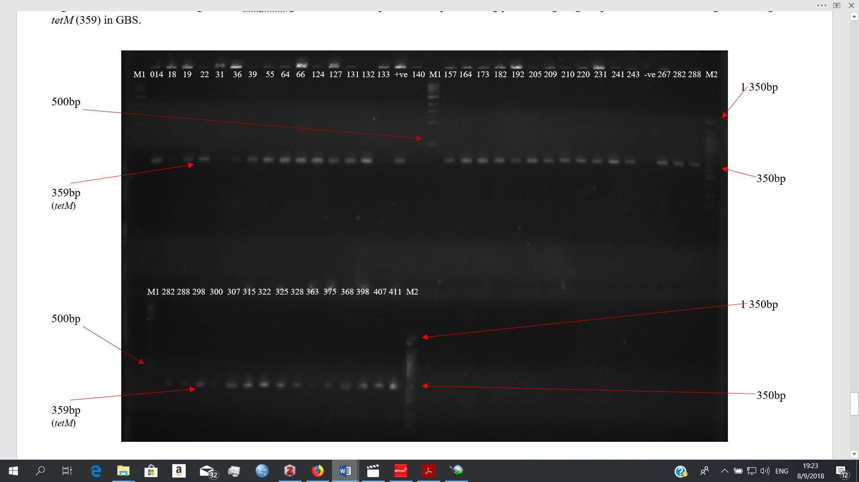Fig 9: Gel electrophoresis of the tetM gene. Lane M1 indicates the lane containing the marker, GeneRuler 1kb Plus DNA Ladder; lane +ve for the positive control; lane -ve for the negative control; while lane M2 indicates the lane with GeneRuler 50bp Plus DNA Ladder. : tetM (359bp) present in all the other 43 GBS isolates except for sample 140

